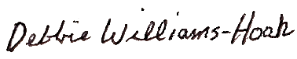

Presented To

~ Name~

Fall 2022

1st Team All-State

Division 2

MIGCA President

Coach